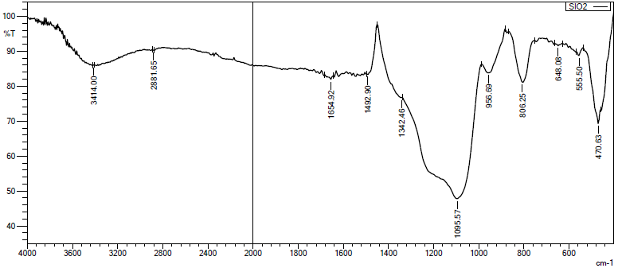Figure S1: FTIR of SiO₂ nanoparticles
Si-O-Si
Si-O-Si
Si-O-H
O-H
O-H
Si-O-Si

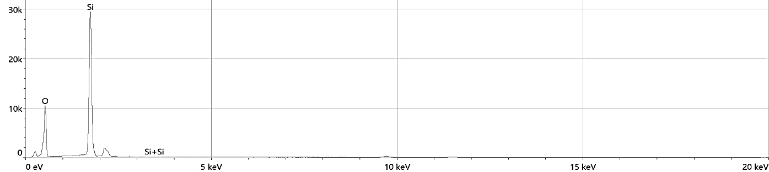

Element | Atomic % | Atomic % Error | Weight % | Weight % Error
O | 64.2 | 0.4 | 50.5 | 0.3
Si | 35.8 | 0.1 | 49.5 | 0.2

Figure S2: EDX of SiO₂ nanoparticles

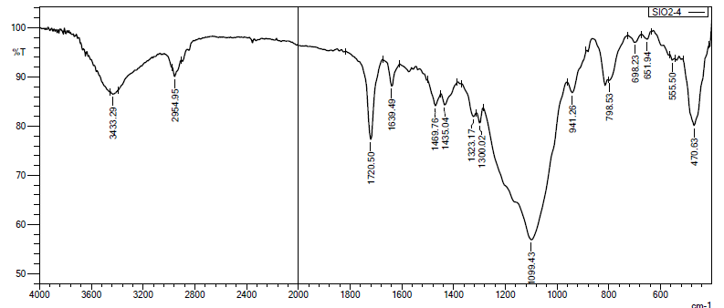
Si-O-Si
Si-O-Si
Si-O-Si
-CH₂
C=C
C=O
-CH₂
O-H
Si-O-Si

Figure S3: FTIR of SiO₂ MPS nanoparticles
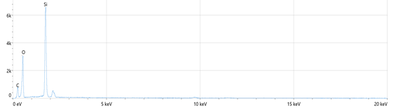

Element | Atomic % | Atomic % Error | Weight % | Weight % Error
C | 27.0 | 0.6 | 19.3 | 0.5
O | 50.6 | 0.5 | 48.1 | 0.5
Si | 22.4 | 0.1 | 32.6 | 0.1

Figure S4: EDX of MPS nanoparticles

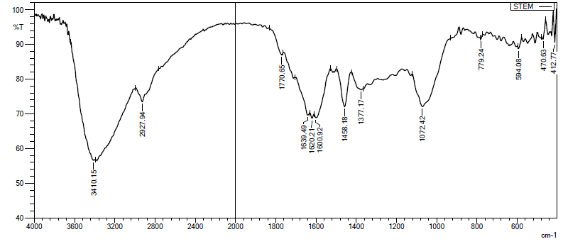
Si-O-Si
Si-O-Si
C=C
C=O
C=O
C-H
exocyclic O-H
Si-O-Si

Figure S5: FTIR of STEM extract

Figure S5: FTIR of STEM extract

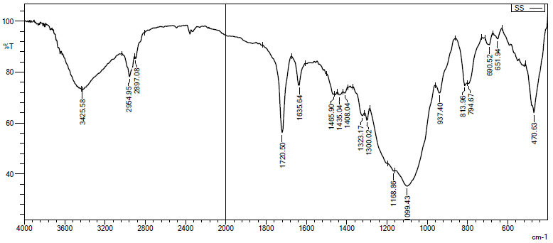
Si-O-Si
Si-O-C
C-S
C-N
C-H
Si-O-C
C=C
C=O
C-H
O-H
Si-O-Si
Figure S6: FTIR of STEM extract@SiO₂ MPS nanoparticles

Figure S6: FTIR of STEM extract@SiO₂ MPS nanoparticles

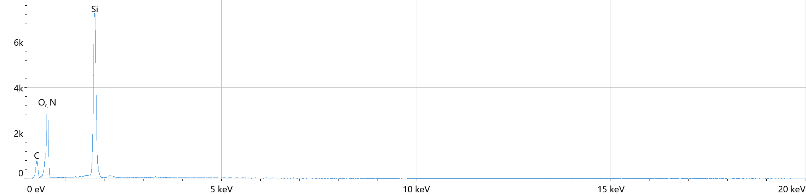

Element | Atomic % | Atomic % Error | Weight % | Weight % Error
C | 26.8 | 0.6 | 19.0 | 0.4
N | 5.1 | 0.9 | 4.2 | 0.7
O | 50.6 | 0.5 | 47.8 | 0.5
Si | 17.5 | 0.1 | 29.0 | 0.1

Figure S7: EDX of MPS-stem extract nanoparticles

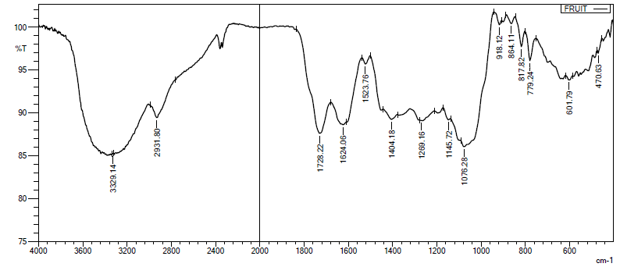
C-C-O
C-O
C=H
C=C
C=C
C=O
C-H
O-H, N-H
Figure S8: FTIR of FRUIT extract
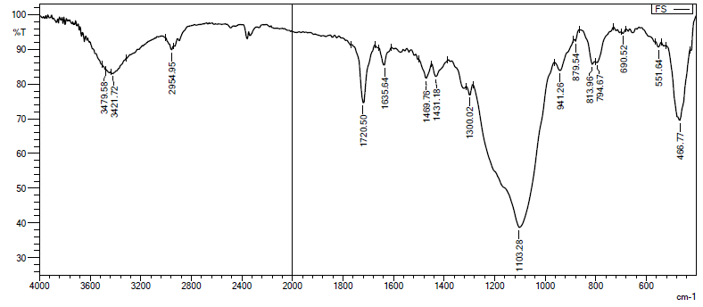
Si-O-Si
Si-O-Si
Si-O-Si
Si-O-C
Si-O-C
C-H
C=C
C=O
C-O
C-H
O-H
Figure S9: FTIR of FRUIT extract@SiO₂ MPS nanoparticles
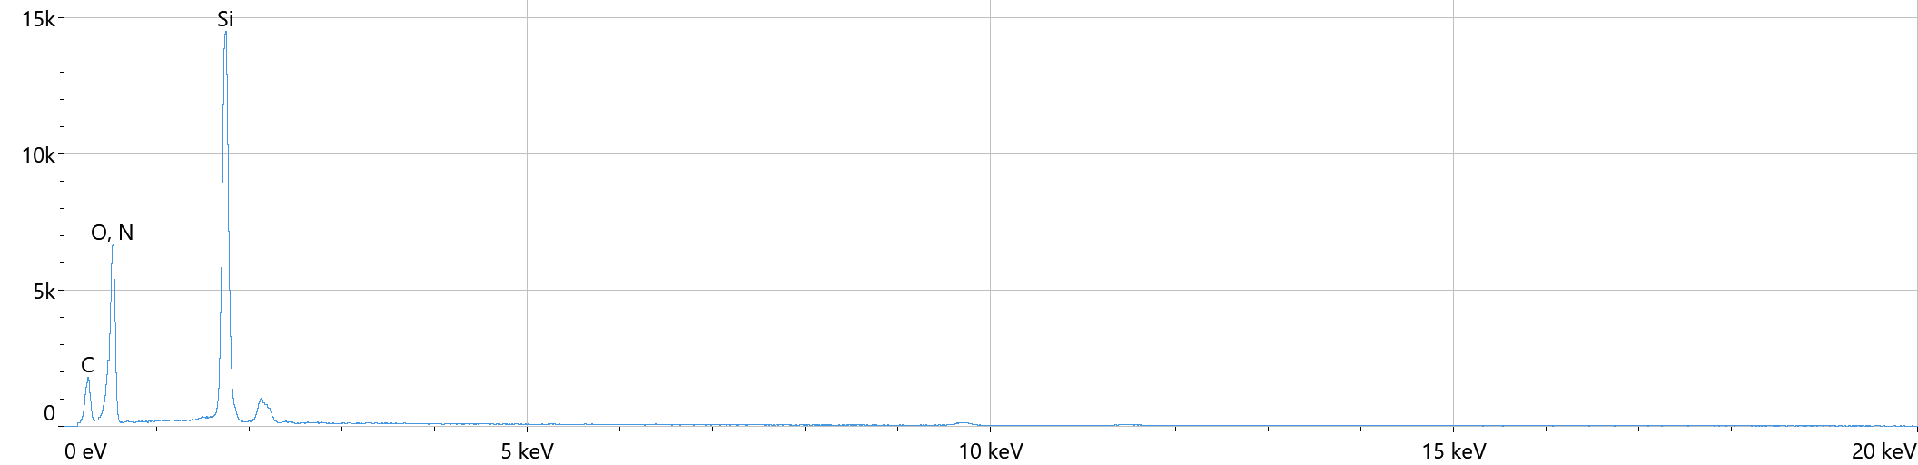

Element | Atomic % | Atomic % Error | Weight % | Weight % Error
C | 27.4 | 0.4 | 19.5 | 0.3
N | 5.3 | 0.6 | 4.4 | 0.5
O | 50.5 | 0.4 | 48.0 | 0.4
Si | 16.8 | 0.1 | 28.0 | 0.1

Figure S10: EDX of MPS-fruit extract nanoparticles

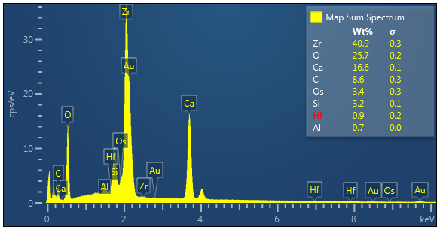
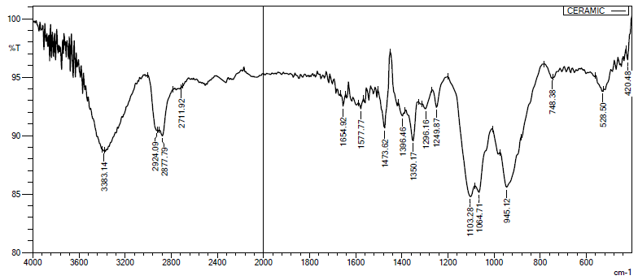
Si-O-Al

Si-O-Ca

Zr-O

Si-O

Zr-OH

Si-OH

C=C
C=O
C-H
O-H

Figure S11: FTIR of bioceramic

Figure S12: EDX of bioceramic

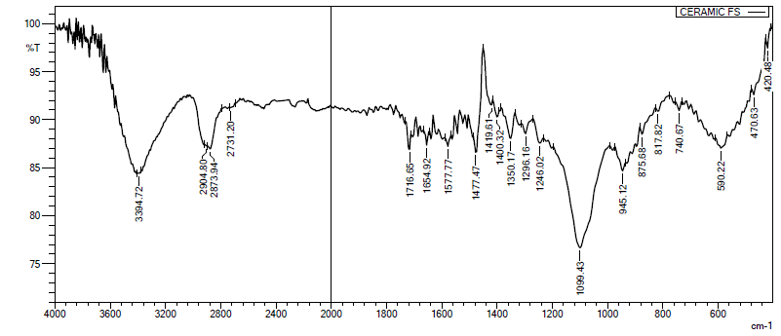
Zr-O
Si-O-Al
Si-O-Ca
Si-O
Si-O-Si
CH₃
C-H
O-H
C=O
C=C
C=C
Figure S13: FTIR of ceramic-SiO₂-MPS-Fruit extract
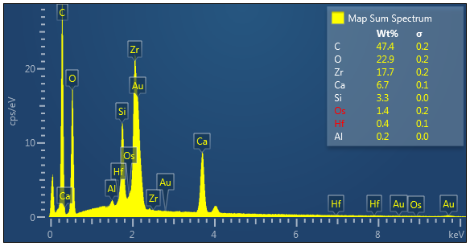

Figure S14: EDX of ceramic-SiO₂-MPS-Fruit extract
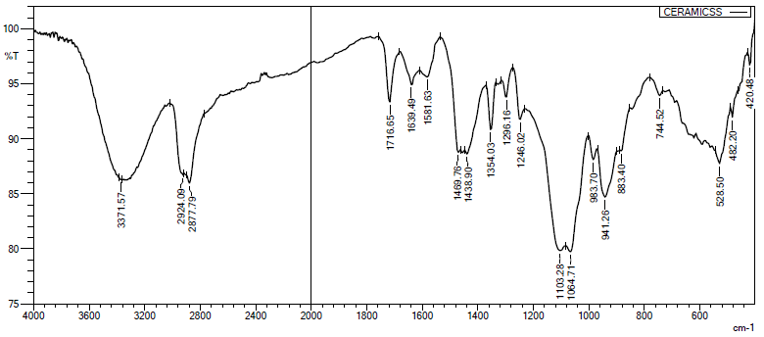
C-H
C=C
C=O
Si-O-C
C-H
O-H
Si-O-Si
Zr-OH
Si-O
Zr-O
Si-O-Si
Si-O-Al or Ca
Si-O-Si
Figure S15: FTIR of ceramic-SiO₂-MPS-Stem extract
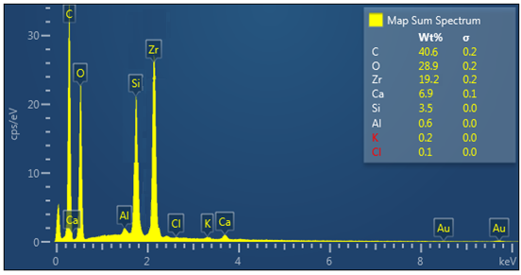

Figure S16: EDX of ceramic-SiO₂-MPS-Stem extract

Table S1: FTIR data of silica nanoparticles
Wavenumber (cm⁻¹) | Functional Group/Vibration
3410 | Hydroxyl (–OH) Stretching
1654 | Hydroxyl (–OH) Bending
1095 | Si–O–Si Bond Stretching (Asymmetrical)
956 | Si–O–H Bond Stretching
806 | Si–O–Si Bond Bending (Symmetrical)
470 | Si–O–Si Bond Bending (Asymmetrical)

Table S2: FTIR information of SiO₂-methacryloxypropyltrimethoxysilane
Wavenumber (cm⁻¹) | Vibrational Mode | Corresponding Functional Group / Bond
3433 | Stretching vibration of -OH groups | Surface hydroxyl groups of SiO₂ nanoparticles
2954 | Asymmetric stretching vibration of -CH₂ groups | Methylene groups in methacryloxypropyltrimethoxysilane
1720 | Stretching vibration of C=O group | Carbonyl group in methacryloxypropyltrimethoxysilane
1630 | Stretching vibration of C=C bond | Carbon-carbon double bond in methacryloxypropyltrimethoxysilane
1459 | Deformation vibration of -CH₂ groups | Methylene groups in methacryloxypropyltrimethoxysilane
1435 | Deformation vibration of -CH₂ groups | Methylene groups in methacryloxypropyltrimethoxysilane
1099 | Stretching vibration of Si-O-Si bond | Si-O-Si bond in SiO₂ nanoparticles
798 | Rocking vibration of Si-O-Si bond | Si-O-Si bond in SiO₂ nanoparticles
470 | Bending vibration of Si-O-Si bond | Si-O-Si bond in SiO₂ nanoparticles

Table S3: FTIR data of STEM extract
Wavenumber (cm⁻¹) | Vibrational Mode | Corresponding Functional Group / Bond
3410 | Stretching vibration | exocyclic O-H group
2927 | Stretching vibration | Aliphatic C-H groups
1770 | Stretching vibration | Carbonyl group (C=O) in ester functional group
1639 | Stretching vibration | Carbonyl group (C=O) in ester functional group
1620 | Stretching vibration | Carbonyl group (C=O) in ester functional group
1600 | Stretching vibration | C=C (vinyl group)
1458 | Deformation vibration | Phenyl group
1377 | Bending vibration | Aliphatic C-H groups
1072 | Stretching vibration | C=O bond in ketone functional group
779 | Rocking vibration | Si-O-Si bond in siloxane group
470 | Bending vibration | Si-O-Si bond in siloxane group

Table S4: FTIR data of SiO₂-3-methacryloxypropyltrimethoxysilane-stem extract
Wavenumber (cm-1) | Vibrational Mode | Corresponding Functional Group / Bond
3425 | O-H stretching vibration | Hydroxyl groups in organic molecules
2954 | C-H stretching vibration | Methylene groups in organic molecules
2897 | C-H stretching vibration | Methyl groups in 3-methacryloxypropyltrimethoxysilane
1720 | C=O stretching vibration | Ester group in 3-methacryloxypropyltrimethoxysilane
1635 | C=C stretching vibration | Vinyl group in 3-methacryloxypropyltrimethoxysilane
1465 | Deformation vibration | CH₂ group in methylene chain of 3-methacryloxypropyltrimethoxysilane
1435 | Deformation vibration | CH₃ group in 3-methacryloxypropyltrimethoxysilane
1408 | Si-O-C stretching vibration | 3-methacryloxypropyltrimethoxysilane
1300 | C-N stretching vibration | Nitrogen-containing organic molecule (1-(N)-hydroxyethyl-9-phenyl-4,5,6,7-tetrahydro[1]benzothieno[2,3-c]pyridine)
1168 | C-O stretching vibration | Ester group in ethyl phthalate
1099 | Si-O stretching vibration | SiO₂-3-methacryloxypropyltrimethoxysilane hybrid material
937 | C-H deformation vibration | Methylene groups in organic molecules
813 | C-S stretching vibration | 1-(N)-hydroxyethyl-9-phenyl-4,5,6,7-tetrahydro[1]benzothieno[2,3-c]pyridine
794 | Deformation vibration | Si-O-C bond in SiO₂-3-methacryloxypropyltrimethoxysilane hybrid material
690 | Bending vibration | Si-O-Si bond in SiO₂-3-methacryloxypropyltrimethoxysilane hybrid material
651 | Bending vibration | Si-O-Si bond in SiO₂-3-methacryloxypropyltrimethoxysilane hybrid material
470 | Si-O-Si stretching vibration | SiO₂-3-methacryloxypropyltrimethoxysilane hybrid material
Table S5: FTIR data of fruit extract
Compound | Vibrational Bands (cm-1) | Functional Groups
5,4'-Dimethoxy-2-methylbibenzyl | 2931, 1624, 1404, 1076 | C-H stretching, aromatic ring, C-H bending, C-O
4,7,7-Trimethylbicyclo[3.3.0]octan-2-one | 1728, 2931, 1076 | Carbonyl stretching, C-H stretching, C-O
Urea N,N'-dibutyl-N,N'-dimethyl | 3329, 1624, 1404, 2931, 2854, 1728 | N-H stretching, C-N stretching, C-N bending, C-H stretching, C=O
Diethyl Phthalate | 1728, 1269, 1145 | Carbonyl stretching, C-O bending, C-C-O bending
Linoleic acid | 2921, 1728, 1624, 1404 | C-H stretching, carbonyl stretching, C=C, CH₂ bending
2-Propylphenanthro[9,10-d]oxazole | 1624, 1523, 1404 | Aromatic ring, C-H bending
Decanedioic acid, bis(2-ethylhexyl) ester | 2931, 1728, 1404 | C-H stretching, carbonyl stretching, C-H bending
N-[2-Hydroxyethyl]succinimide | 3329, 1728, 1624, 1404 | N-H/O-H stretching, carbonyl stretching, C-H bending

Table S6: FTIR data of SiO₂-3-methacryloxypropyltrimethoxysilane-fruit extract
Wavenumber (cm⁻¹) | Vibrational Mode | Corresponding Functional Group / Bond
3479 | O-H stretching | Hydrogen-bonded hydroxyl groups
3421 | O-H stretching | Hydroxyl groups
2954 | C-H stretching | Aliphatic C-H bonds
1720 | C=O stretching | Carbonyl groups (esters, ketones, carboxylic acids)
1635 | C=C stretching | Double bonds
1469 | C-H bending | Alkane or alkene groups
1431 | C-H bending | Methylene group
1300 | C-O stretching | Ether groups
1103 | Si-O-C stretching | Siloxane bond
941 | C-H bending | Various organic groups
879 | Si-O-C stretching | Siloxane bond
813 | Si-O-Si stretching | Silicates
794 | Si-O-C stretching | Siloxane bond
690 | Si-O-Si bending | Silicate groups
551 | Si-O-Si stretching | Silicates
466 | Si-O-Si bending | Silicate groups
Table S7: FTIR data of bioceramic
Wavenumber (cm⁻¹) | Vibrational Mode | Corresponding Functional Group / Bond
3383 | Stretching vibration | O-H (hydroxyl) groups
2924, 2877 | Stretching vibration | C-H (methyl and methylene) groups
1654 | Stretching vibration | Carbonyl group (C=O)
1577 | Stretching vibration | Aromatic C=C bonds
1473 | Deformation vibration | CH₃ (methyl) groups
1350 | Bending vibration | C-H bonds in alkane groups
1103 | Stretching vibration | Si-OH (silanol) groups
1064 | Stretching vibration | Zr-OH (zirconium-oxygen-hydrogen) bonds
945 | Stretching vibration | Si-O (silicon-oxygen) bonds
528 | Bending vibration | Si-O-Ca or Si-O-Al bonds
420 | Bending vibration | Zr-O (zirconium-oxygen) bonds

Table S8: FTIR data of ceramic-SiO₂-MPS-Fruit extract
Wavenumber (cm⁻¹) | Vibrational Mode | Corresponding Functional Group / Bond
3394 | O-H stretching | Hydroxyl groups
2904, 2873 | C-H stretching | Methyl and methylene groups
1716 | C=O stretching | Carbonyl groups
1654, 1577 | C=C stretching | Aromatic compounds
1477 | Deformation vibration | CH₃ groups (methyl groups)
1350 | Bending vibration | C-H bonds in alkane groups
1099 | Si-OH stretching | Silanol groups and Zirconium hydroxide, possibly Ca-Si-O and Al-Si-O
945 | Si-O stretching | Silicate groups
590 | Bending vibration | Si-O-Ca or Si-O-Al bonds (silicate groups)
Table S9: FTIR data of ceramic-SiO₂-MPS-Stem extract
Wavenumber (cm⁻¹) | Vibrational Mode | Corresponding Functional Group / Bond
3371 | O-H stretching | Hydroxyl groups
2924, 2877 | C-H stretching | Methyl and methylene groups
1716 | C=O stretching | Carbonyl groups
1639 | C=C stretching | Vinyl group in 3-methacryloxypropyltrimethoxysilane
1581 | C=C stretching | Aromatic compounds
1469 | Deformation vibration | CH₂ group in 3-methacryloxypropyltrimethoxysilane
1438 | Deformation vibration | CH₃ group in 3-methacryloxypropyltrimethoxysilane
1354 | Bending vibration | C-H bonds in alkane groups
1296 | Si-O stretching | Silicon-oxygen bonds (silicate groups)
1246 | Si-O-C stretching | 3-methacryloxypropyltrimethoxysilane
1103 | Si-OH stretching | Silanol groups
1064 | Zr-OH stretching | Zirconium hydroxide, Ca-Si-O, Al-Si-O
941 | Si-O stretching | Silicon-oxygen bonds (silicate groups)
744 | Bending vibration | Si-O-Si bonds in SiO₂-3-methacryloxypropyltrimethoxysilane hybrid
528 | Bending vibration | Si-O-Ca or Si-O-Al bonds (silicate groups)
482 | Bending vibration | Si-O-Si bond in SiO₂-3-methacryloxypropyltrimethoxysilane hybrid
420 | Bending vibration | Zr-O bending (zirconium-oxygen bonds)

